A Project Report on

### HABRI INVENTORY MANAGEMENT SYSTEM

At



### L.D. COLLEGE OF ENGINEERING [MCA]

Navrangpura, Ahmedabad.

As A Fulfilment for the Degree Of Master of Computer Application (M. C. A.) 2022-2023

|  |  |
| --- | --- |
| **Guided By:**  **Prof.** Jaimin Chavda | **Submitted By:**  **Mr.** Daniel O.U Mapala  **215160694035**  **Mr.** Noor Rahim Shir Afzal  **215160694038** |

L.D. COLLEGE OF ENGINEERING [MCA] Navrangpura, Ahmedabad.

Affiliated To

### Gujarat Technological University

 

# L.D. COLLEGE OF ENGINEERING

NAVRANGPURA, AHMEDABAD- 380015

***CERTIFICATE***

This is to certify that Software Development Project entitled **HABRI INVENTORY MANAGEMENT SYSTEM** is developed and submitted to Gujarat Technological University by **Mr**. **Daniel Overton Unique Mapala (E.No.215160694035)** fulfilment of the requirement of MCA **Semester 4** for the award of the **Master of Computer Applications (M.C.A.)** in the year 2022- 2023.

This is the original work and carried out under my guidance and supervision. We further certify that to the best of our knowledge and belief the matter presented in this project report is Bonafide work.

### DATE OF SUBMISSION:

**Prof. Jaimin Chavda Dr Hitieshi Diwanji Prof.**

Asst. Professor (IT), HOD, IT-MCA

LDCE, Ahmedabad LDCE, Ahmedabad (External External)

 

**L.D. COLLEGE OF ENGINEERING**

NAVRANGPURA, AHMEDABAD: 380015

***CERTIFICATE***

This is to certify that Software Development Project entitled **HABRI INVENTORY MANAGEMENT SYSTEM** is developed and submitted to Gujarat Technological University by **Mr. Noor Rahim Shir Afzal (E.No.215160694038)** fulfilment of the requirement of MCA **Semester 4** for the award of the **Masterof Computer Applications** in the year 2022- 2023.

This is the original work and carried out under my guidance and supervision. We further certify that to the best of our knowledge and belief the matter presented in this project report is Bonafide work.

### DATE OF SUBMISSION:

**Prof. Jaimin Chavda Dr Hitieshi Diwanji Prof.**

Asst. Professor (IT), HOD, IT-MCA

LDCE, Ahmedabad LDCE, Ahmedabad (External External)

 

**L.D. COLLEGE OF ENGINEERING NAVRANGPURA, AHMEDABAD: 380015**

***DECLARATION***

We hereby declare that the Project report submitted with the Project entitled “**HABRI INVENTORY MANAGEMENT SYSTEM**”

submitted in partial fulfilment for the degree of **Master of Computer Application** in L. D. College of Engineering-MCA Program to Gujarat Technological University, Ahmedabad, is a bonafide record of original project work carried out by us at L. D. College of Engineering under the guidance of **Prof. Jaimin Chavda** and External Guide **Happy Abraham Manda** ( MD, Habri Investment), and no part of this report has been directly copied from any student’s report or taken from any other source, without providing due reference.

### Name of Student: Signature of Student

**Daniel O.U Mapala: ………………………..**

### 215160694035

**Noor Rahim Shir Afzal: …………………………**

**215160694038**

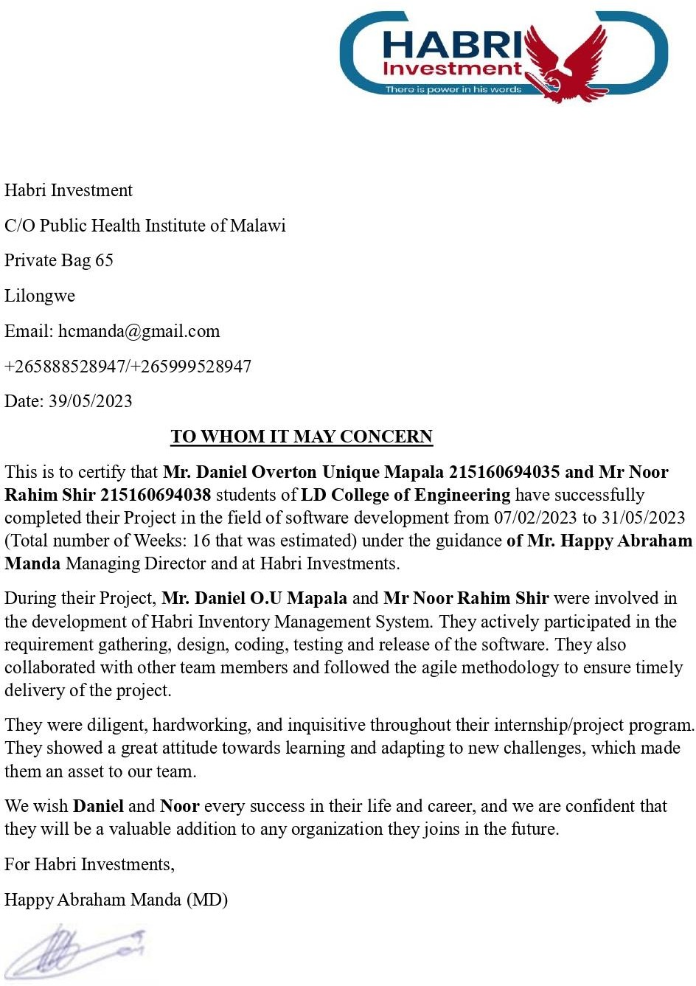

## Acknowledgement

It is our great Pleasure to express our deep sense of gratitude to our college L.D. College of Engineering.

We wish to express our sincere gratitude to our internal project guide **Prof. Jaimin Chavda f**or providing his invaluable guidance, comments and suggestions on the project. His prompt inspiration on project. His, valuable experience and dynamism have enabled us to succeed in the project. We also Appreciate External Guide who is the owner and founder of Habri investment **Happy Abraham Manda** where the model of the system has been developed for management of Inventory of Medium and small SMES

We would also like to thank the whole MCA Department for the knowledge imparted in us that has also helped us to be able to achieve this project

Once again, we are grateful to all those without whom this work would not have been successful Family members and **ICCR** for moral and Financial Support.

#### Thank you so much,

**Mr. DANIEL OVERTON UNIQUE MAPALA: …………………………………**

#### Mr. NOOR RAHIM SHIR AFZAL: …………………………………………..

i

|  |  |  |  |  |
| --- | --- | --- | --- | --- |
|  | HABRI INVENTORY MANAGEMENT SYSTEM  **Preface**  As a part of MCA Curriculum and in order to gain practical knowledge in the field of computer science and Software Development and Industrial experience of real life Problem. We are required to make a project on **“HABRI INVENTORY MANAGEMENT SYSTEM”**. The Basic objective behind doing this project is to develop Web based system that can help any medium or small enterprise to manage their inventory.  Doing this project, it helped us to enhance our knowledge regarding the working of web-based system. We undergo many experiences related with our topic. Through this project, we come to know about importance of dedication, consistency and devotion to work. | | |  |
| **LDCE** | ii | **Gujarat Technological Universi**ty |

|  |  |  |  |  |
| --- | --- | --- | --- | --- |
|  | HABRI INVENTORY MANAGEMENT SYSTEM  **Abstract**  Habri Investment was established in 2017 by Happy Abraham Manda and is based in Mzimba Boma, Malawi. The company specializes in the sales of various products, including plastics, electronics, and groceries. Despite their growth and success, Habri Investment is currently using a manual system to manage their business operations. However, as the company continues to expand, there is a growing need to adopt modern tools that can improve their operations' efficiency.  To address this need, the company has decided to develop an inventory management system. The system will help Habri Investment keep track of their stock levels, sales, reports, and purchases, allowing them to manage their inventory efficiently and prevent stock shortages or overstocking. The proposed inventory management system will be developed using modern technologies such as Laravel Framework, PHP, CSS, JavaScript, HTML, SQL, and Bootstrap, ensuring that it meets the company's needs and provides a seamless user experience.  This project aims to develop a customized inventory management system that aligns with Habri Investment's unique business needs. The system's development will be guided by industry best practices, with a focus on enhancing inventory management efficiency and streamlining business operations. The implementation of the inventory management system will help Habri Investment optimize their operations, enhance customer satisfaction, and ultimately, drive business growth. | | |  |
| **LDCE** | iii | **Gujarat Technological Universi**ty |

|  |  |  |  |  |
| --- | --- | --- | --- | --- |
|  | HABRI INVENTORY MANAGEMENT SYSTEM  **List of Figures Page**  Figure 1: Gantt chart 3  Figure 2: General use case 8  : 2.1 Warehouse manager user case 10  : 2.2 Sales person use case 12  : 2.3 Accounting Person Use case 13  : 2.4 Purchase officer use case 15  Figure 3: Class Diagram 17  Figure 4: Interaction Diagram 18  Figure 5: Activity Diagram 19  Figure 6: ERD 20  Figure 7-8.6 Screenshot /UI design 22-40  Figure 9: Agile Project Plan 44  Figure 10: Agile Burn down Chart 48 | | |  |
| **LDCE** | iv | **Gujarat Technological Universi**ty |

|  |  |  |  |  |
| --- | --- | --- | --- | --- |
|  | HABRI INVENTORY MANAGEMENT SYSTEM  **List of Tables Page**  Table 1: Project Plan 3  Table 2: Technology Specification 7  Table 3: Agile Project Chart 41-42  Table 4: Agile Road Map/Schedule 43  Table 5: Agile Release Plan 44  Table 6: Agile Spirit Backlog 47  Table 7: Agile Test Plan 47 | | |  |
| **LDCE** | v | **Gujarat Technological Universi**ty |

|  |  |  |  |  |
| --- | --- | --- | --- | --- |
|  | HABRI INVENTORY MANAGEMENT SYSTEM  **List of Symbols, Abbreviations and Nomenclature**  API - Application Programming Interface CRUD - Create, Read, Update, Delete DBMS - Database Management System GUI - Graphical User Interface  HTML - Hypertext Markup Language HTTP - Hypertext Transfer Protocol JSON - JavaScript Object Notation MVC - Model-View-Controller  ORM - Object-Relational Mapping PHP - Hypertext Preprocessor  REST - Representational State Transfer SRS - Software Requirements Specification UI - User Interface  URL - Uniform Resource Locator XML - Extensible Markup Language WM – warehouse Manager  PO – Purchase Officer SP- Salse person | | |  |
| **LDCE** | vi | **Gujarat Technological Universi**ty |

|  |  |  |  |  |
| --- | --- | --- | --- | --- |
|  | HABRI INVENTORY MANAGEMENT SYSTEM  Table of Contents   1. **CHAPTER 1: INTRODUCTION** 1    1. Existing System 1    2. Need for New System 1    3. Objectives of the New System 2    4. Problem Definition 2    5. Core Components: 2    6. Project Profile 3    7. Assumptions & Constraints 4    8. Advantages and Limitations of the Proposed System 4       1. Advantages 4       2. Limitations 4    9. Proposed Time Line Chart 5 2. **CHAPTER : REQUIREMENT DETERMINATION & ANALYSIS** 6    1. Requirement Determination 6    2. Targeted Users 6    3. Requirement Specification 6    4. Hardware Requirements 6    5. Software Requirements 7    6. Technology Specification 7 3. **CHAPTER: SYSTEM DESIGN** 8    1. Use Case Diagram 8    2. Class Diagram 18    3. Interaction Diagram 19    4. Activity Diagram 20    5. Data Dictionary 21 4. **CHAPTER: DEVELOPMENT** 22    1. Coding Standards: 22    2. Screenshot and User Interface Design 23 5. **CHAPTER: DEVELOPMENT** 42    1. Agile Project Charter 42    2. Agile Roadmap/ Schedule 44    3. Agile Project Plan 45    4. Agile User Story (Minimum 3 Tasks) 45    5. Agile Release Plan 46    6. Agile Sprint Backlog 47 | | |  |
| **LDCE** | vii | **Gujarat Technological Universi**ty |

|  |  |  |  |  |
| --- | --- | --- | --- | --- |
|  | HABRI INVENTORY MANAGEMENT SYSTEM   * 1. Agile Test Plan 48   2. Agile Burn down chart 49  1. **CHAPTER: LEARNING DURING PROJECT WORK** 50 2. **CHAPTER: PROPOSED ENHANCEMENTS** 52 3. **CHAPTER: CONCLUSION** 53 4. **CHAPTER REFERENCES/BIBLIOGRAPHY** 54 | | |  |
| **LDCE** | viii | **Gujarat Technological Universi**ty |

## CHAPTER 1: INTRODUCTION

An inventory management system is an essential tool for any business that deals with physical goods. The system helps businesses keep track of their **stock levels, sales, Reports, and purchases.** It enables businesses to manage their inventory efficiently and prevent stock shortages or overstocking. In this report, we will discuss an inventory management system that will be developed using Laravel Framework, PHP, CSS, JavaScript, HTML and Bootstrap.

### Existing System:

The current inventory management system used by the Company is manual. The system involves tracking stock levels, sales, and purchases on a paper-based system. The manual system is prone to errors, time-consuming, and requires a lot of effort to manage.

The Company is facing challenges in managing their inventory, and the manual system is no longer effective.

### Need for New System:

The need for the new inventory management system is to replace the current manual system that is no longer effective. The Company requires an automated system that can help them manage the following:

* + - Inventory efficiently
    - Reduce errors
    - Improve their overall productivity. The new system will provide:
    - Real-time data,
    - Automate repetitive tasks,
    - Streamline the inventory management process.

**LDCE** 1 **Gujarat Technological Universi**ty

### Objectives of the New System:

The objective of the new inventory management system is to provide an efficient and effective tool for managing the organization's inventory. The system will help the organization to:

* + - Reduce errors and inaccuracies in inventory management
    - Improve productivity by automating repetitive tasks
    - Streamline the inventory management process
    - Provide real-time data for better decision making
    - Optimize inventory levels to reduce costs and improve profitability
    - Provide Reports and Statistic

### Problem Definition:

The Company is facing challenges in managing their inventory, and the manual system is no longer effective. The Company requires an automated system that can help them manage their inventory efficiently, reduce errors, and improve their overall productivity.

### Core Components:

The core components of the inventory management system are:

1. **Transaction Management:** This component involves adding, sales, Expenses, Income, Transfers and Payment in the inventory.
2. **Client Management:** This component involves managing Client, and tracking customer orders.
3. **Suppliers/Providers Management:** This component involves view and manage supplier or provider information, such as purchase orders and delivery schedules.
4. **Account Management:** This Component involves methods used to pay for goods or services purchased from the business. In an inventory management system, the payment feature tracks the different payment methods used by customers, and provides an overview of the most popular payment methods.

**LDCE** 2 **Gujarat Technological Universi**ty

|  |  |  |  |  |  |
| --- | --- | --- | --- | --- | --- |
| **215160694035/215160694038 HABRI INVENTORY MANAGEMENT SYSTEM**   1. **Inventory Management:** This component involves managing inventory levels, tracking stock movements, and generating inventory reports. 2. **Reporting and Analytics:** - The system will provide a variety of reports and analytics to help the user track inventory levels, sales performance, and purchasing trends. 3. **User Management: -** the system will allow the administrator to manage user accounts, including creating and deleting accounts, assigning roles and permissions, and resetting passwords.   **1.6 Project Profile:**  The inventory management system will be developed using Laravel Framework, a PHP web application framework. The system will be developed using a three-tier architecture, comprising of the presentation layer, business layer, and data access layer. The system will be designed to be scalable, modular, and flexible to meet the organization's future needs. | | | | | |
|  | Project Definition | INVENTORY MANAGEMENT SYSTEM | | |  |
| Team ID | G07 | | |
| Industry Type | WEB BASED APPLICATION | | |
| Team Details: | DANIEL OVERTON UNIQUE MAPALA  **(215160694035)**  NOOR RAHIM SHIR AFZAL **(215160694038)** | | |
| Mentor Details | PROF. JAIMIN CHAVDA | | |
|  | **Table 1: Project Profile** | | | |  |
| **LDCE** | | | 3 | **Gujarat Technological Universi**ty | |

**215160694035/215160694038 HABRI INVENTORY MANAGEMENT SYSTEM**

### Assumptions & Constraints

The following assumptions and constraints have been made during the development of the inventory management system:

* + - The system will be developed using Laravel Framework.
    - The system will be designed to be scalable, modular, and flexible.
    - The system will be able to manage a large number of products, sales, and purchases.
    - The system will be designed to be user-friendly and intuitive.
    - The system will be tested extensively to ensure it is bug-free and reliable.

### Advantages and Limitations of the Proposed System:

#### Advantages:

* The new system will reduce errors and inaccuracies in inventory management.
* The system will improve productivity by automating repetitive tasks.
* The system will streamline the inventory management process.
* The system will provide real-time data for better decision making.
* The system will optimize inventory levels to reduce costs and improve profitability.

#### Limitations:

* The system will require training for staff to use it effectively.
* The system may require additional hardware and software to run effectively.
* The system may be expensive to develop and maintain.
* The system may not be suitable for Very big businesses with.

**LDCE** 4 **Gujarat Technological Universi**ty

**215160694035/215160694038 HABRI INVENTORY MANAGEMENT SYSTEM**

### Proposed Time Line Chart:

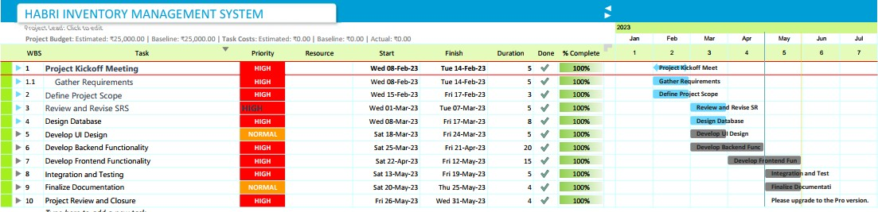

**Figure 1 : Gantt chart**

**LDCE** 5 **Gujarat Technological Universi**ty

**215160694035/215160694038 HABRI INVENTORY MANAGEMENT SYSTEM**

## CHAPTER : REQUIREMENT DETERMINATION & ANALYSIS

### Requirement Determination

To determine the requirements for the inventory management system, the following steps were taken:

* + - Conducted interviews with stakeholders to gather their requirements and expectations from the system
    - Analyzed the current manual system to identify its strengths and weaknesses
    - Conducted market research to identify the latest trends and technologies in inventory management systems
    - Identified the key features and functionalities that the system must have to meet the organization's needs
    - Prioritized the requirements based on their importance and feasibility

### Targeted Users:

The targeted users of the inventory management system are employees of the Company who are involved in inventory management, such as:

1. Warehouse Managers
2. Sales Representatives
3. Purchase Officers
4. Accounting Officers

### Requirement Specification:

#### Hardware Requirements

Processor : **Intel i5**

RAM : **8 GB or higher**

Hard Disk : **120 GB**

I/O Devices : **Monitor, Scanner and printer etc**

**LDCE** 6 **Gujarat Technological Universi**ty

|  |  |  |  |  |  |
| --- | --- | --- | --- | --- | --- |
| **215160694035/215160694038 HABRI INVENTORY MANAGEMENT SYSTEM**   * 1. **Software Requirements**      1. Operating System : **Windows 10**      2. Documentation : **MS office -2016**      3. For Diagram : **Microsoft Visio, Visual Paradigm**      4. IDE **: Visual studio code**      5. **sublime text**   2. **Technology Specification** | | | | | |
|  | **Technology** | **Purpose in Project**  **Development** | **Description** | |  |
| Laravel Framework | Backend Framework | A PHP web application framework that provides a robust set of tools and features for  building scalable web projects. | |
| Backend PHP | Server-Side Logic | PHP is a server-side scripting language used to handle backend logic, interact with  databases, and process requests. | |
| HTML | Structure and Content | HTML (Hypertext Markup Language) is used for creating the structure and content of  web pages. | |
| CSS | Styling | CSS (Cascading Style Sheets) is used to define the visual styles and layout of HTML  elements on web pages. | |
| JavaScript | Client-Side Interactivity | JavaScript is a programming language used  to add interactivity, dynamic behavior, and logic to web applications. | |
| Bootstrap | Responsive Design | Bootstrap is a popular CSS framework that  provides pre-built responsive components and styles for web development. | |
| jQuery | DOM Manipulation | jQuery is a JavaScript library used for simplifying the manipulation and traversal of  HTML documents in the browser. | |
| MySQL | Database Management | MySQL is a relational database management system (RDBMS) used for storing and  retrieving data in web applications. | |
| XAMPP | Local Development Environment | XAMPP is a software package that provides a local development environment with Apache, MySQL, PHP, and Perl for testing  and debugging web applications. | |
|  | **Table 2** | | | |  |
| **LDCE** | | | 7 | **Gujarat Technological Universi**ty | |

## CHAPTER: SYSTEM DESIGN

### Use Case Diagram:

The use case diagram for the inventory management system is shown below:

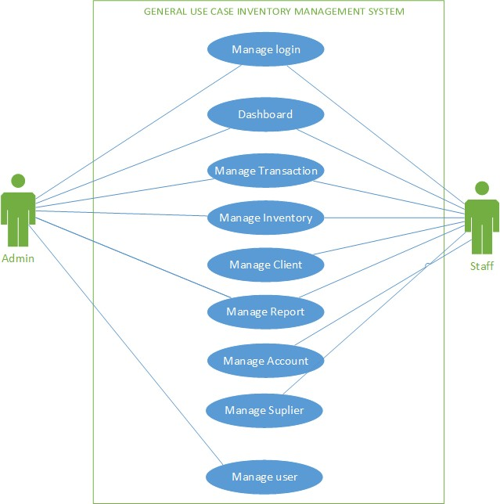

#### Figure 2

**LDCE** 8 **Gujarat Technological Universi**ty

### Admin Use Case:

* + - **System setup and maintenance:** The system administrator is responsible for setting up the inventory management system and ensuring that it is properly maintained. This may include installing the necessary software, configuring the system, and ensuring that it is up to date with the latest patches and updates.
    - **User management:** The system administrator may be responsible for managing user accounts and permissions within the system. This may include creating new user accounts, assigning permissions and access levels, and deactivating or deleting user accounts as needed.
    - **Data management:** The system administrator may be responsible for managing the data within the inventory management system. This may include backing up data, monitoring data integrity, and ensuring that data is properly stored and secured.
    - **Troubleshooting:** The system administrator may be responsible for troubleshooting any issues that arise with the inventory management system. This may involve identifying and resolving system errors, identifying performance issues, and troubleshooting issues with user accounts or permissions.

**LDCE** 9 **Gujarat Technological Universi**ty

#### Warehouse Manager use case:

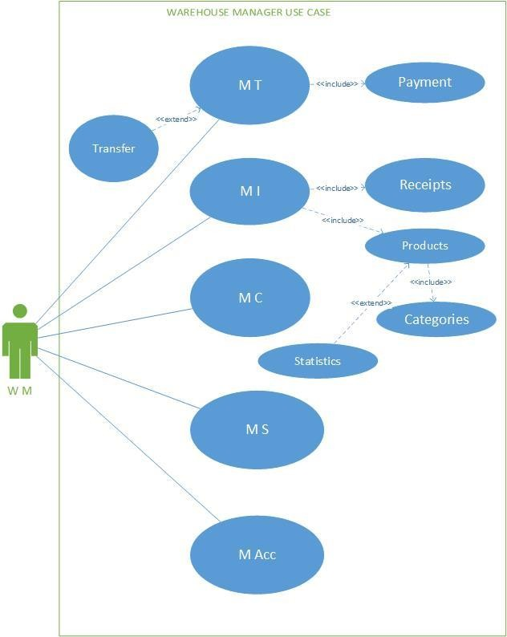

**Figure 2.1**

**LDCE** 10 **Gujarat Technological Universi**ty

### Warehouse Manager:

* + - * **Manage Transaction:** Warehouse managers can view and manage all incoming and outgoing transactions related to the inventory, including tracking inventory levels and updating inventory records.
      * **Manage Inventory:** Warehouse managers can add, remove, or update inventory items in the system. They can also track inventory levels and generate inventory reports.
      * **Manage Client:** Warehouse managers can view and manage client information, such as orders and delivery schedules.
      * **Manage Suppliers or Providers:** Warehouse managers can view and manage supplier or provider information, such as purchase orders and delivery schedules.
      * **Manage Payment Method and Accounts:** Warehouse managers can view and manage payment information, such as invoices and receipts, as well as update account information.

**LDCE** 11 **Gujarat Technological Universi**ty

#### Sales person Use Case:

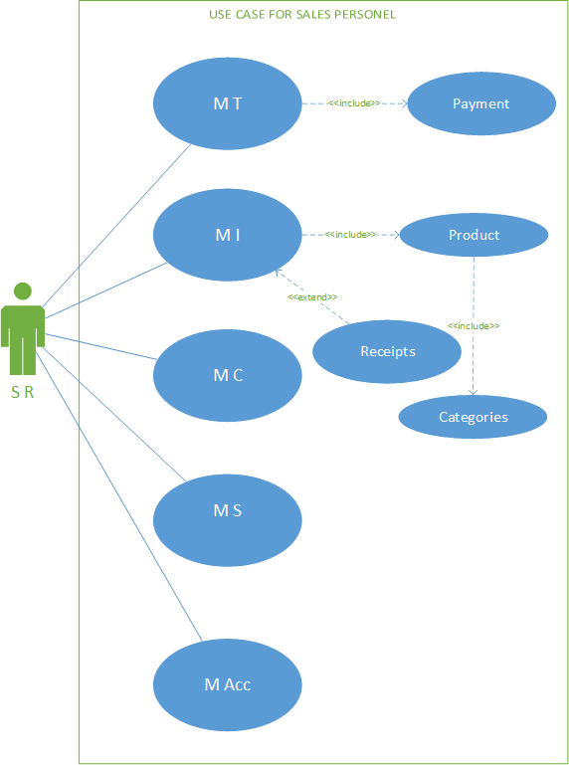

**Figure 2.2**

**LDCE** 12 **Gujarat Technological Universi**ty

### Sales person Use Case:

* + - **Manage Transaction:** Sales representatives can view and manage sales transactions related to the inventory, including creating sales orders and generating sales reports.
    - **Manage Inventory:** Sales representatives can view and search inventory items in the system. They can also update inventory records and generate inventory reports.
    - **Manage Client:** Sales representatives can view and manage client information, such as orders and delivery schedules.
    - **Manage Suppliers or Providers:** Sales representatives can view and manage supplier or provider information, such as purchase orders and delivery schedules.
    - **Manage Payment Method and Accounts:** Sales representatives can view and manage payment information, such as invoices and receipts, as well as update account information.

**LDCE** 13 **Gujarat Technological Universi**ty

**Accounting Officer Use Case:**

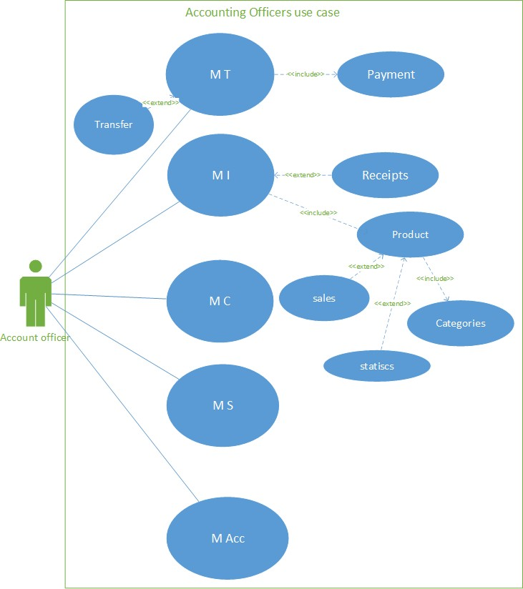

### Figure 2.3

**LDCE** 14 **Gujarat Technological Universi**ty

### Accounting Officer Use Case:

* + - **Manage Transaction:** Accounting officers can view and manage all financial transactions related to the inventory, including creating and managing invoices, and generating financial reports.
    - **Manage Inventory:** Accounting officers can view and search inventory items in the system. They can also update inventory records and generate inventory reports.
    - **Manage Client**: Accounting officers can view and manage client information, such as orders and delivery schedules.
    - **Manage Suppliers or Providers:** Accounting officers can view and manage supplier or provider information, such as purchase orders and delivery schedules.
    - **Manage Payment Method and Accounts:** Accounting officers can view and manage payment information, such as invoices and receipts, as well as update account information.

**LDCE** 15 **Gujarat Technological Universi**ty

**Purchasing Officer Use case:**

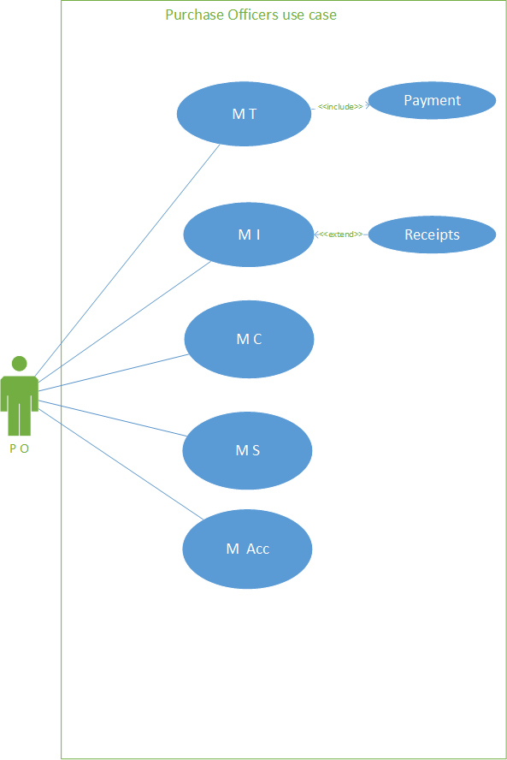

### Figure 2.4

**LDCE** 16 **Gujarat Technological Universi**ty

### Purchasing Officer Use case:

* + - **Manage Transaction:** Purchase officers can view and manage purchase transactions related to the inventory, including creating purchase orders and generating purchase reports.
    - **Manage Inventory:** Purchase officers can view and search inventory items in the system. They can also update inventory records and generate inventory reports.
    - **Manage Client:** Purchase officers can view and manage client information, such as orders and delivery schedules.
    - **Manage Suppliers or Providers:** Purchase officers can view and manage supplier or provider information, such as purchase orders and delivery schedules.
    - **Manage Payment Method and Accounts:** Purchase officers can view and manage payment information, such as invoices and receipts, as well as update account information.

**LDCE** 17 **Gujarat Technological Universi**ty

### Class Diagram:

The class diagram for the inventory management system is shown below:

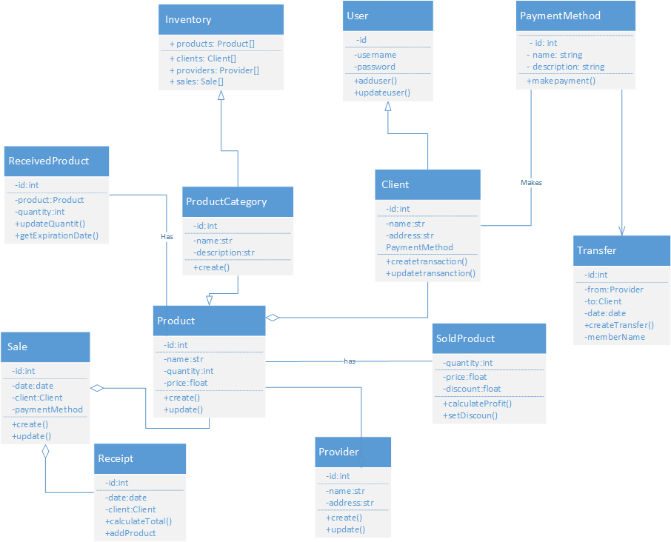

#### Figure 3

**LDCE** 18 **Gujarat Technological Universi**ty

### Interaction Diagram:

The interaction diagram for the inventory management system is shown below:

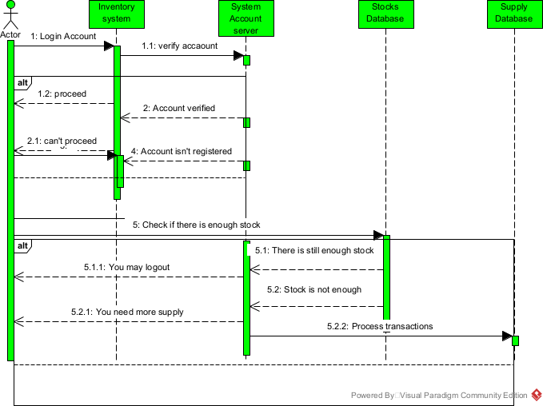

**Figure 4**

**LDCE** 19 **Gujarat Technological Universi**ty

### Activity Diagram:

The activity diagram for the inventory management system is shown below:

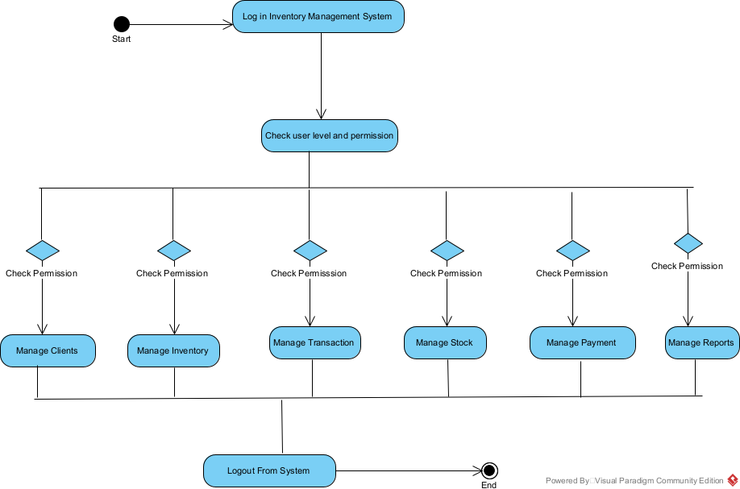

#### Figure: 5

**LDCE** 20 **Gujarat Technological Universi**ty

### Data Dictionary:

#### Figure 6

**LDCE** 21 **Gujarat Technological Universi**ty

## CHAPTER: DEVELOPMENT

### Coding Standards:

The inventory management system was developed using Laravel Framework, following the PSR-1 and PSR-2 coding standards. The code was also reviewed by a team of developers to ensure it is maintainable, readable, and adheres to best practices.

**LDCE** 22 **Gujarat Technological Universi**ty

### Screenshot and User Interface Design

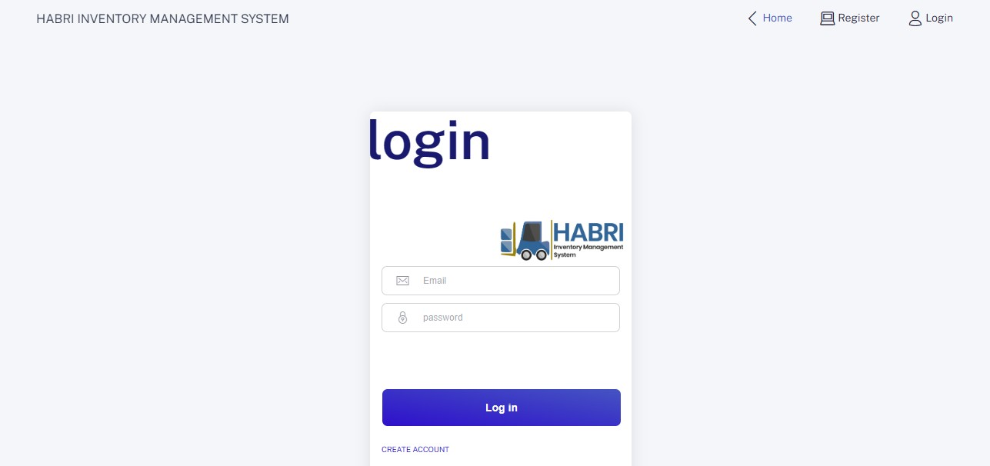

**Figure 7:** Home page (for login and registering user)

**LDCE** 23 **Gujarat Technological Universi**ty

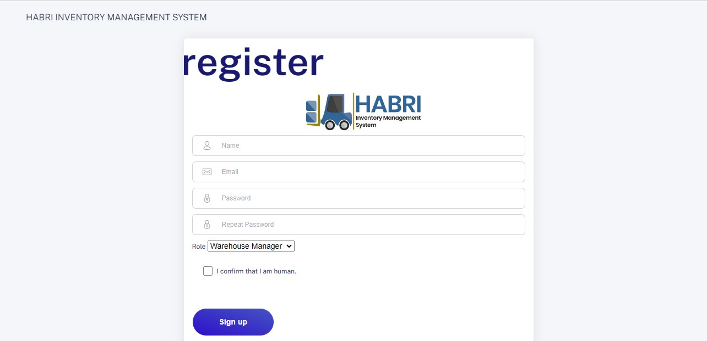

**Figure 7.1:** Page to Register.

**LDCE** 24 **Gujarat Technological Universi**ty

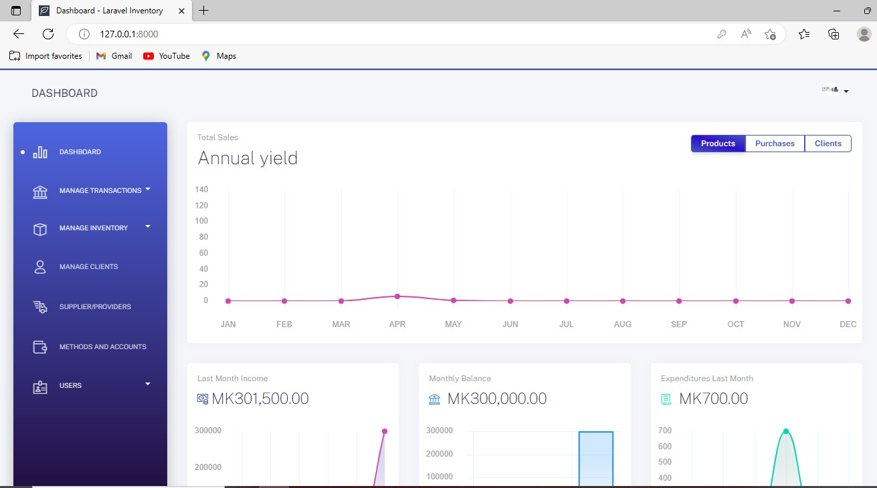

**Figure 7.2:** Dashboard

**LDCE** 25 **Gujarat Technological Universi**ty

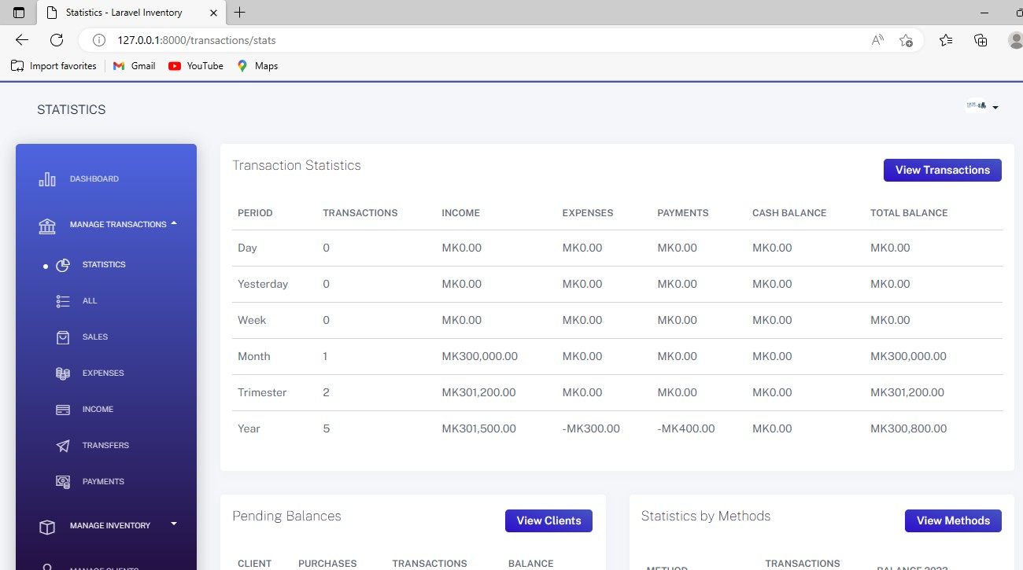

**Figure 7.3:** Manage Transaction (Transaction Statistics by period)

**LDCE** 26 **Gujarat Technological Universi**ty

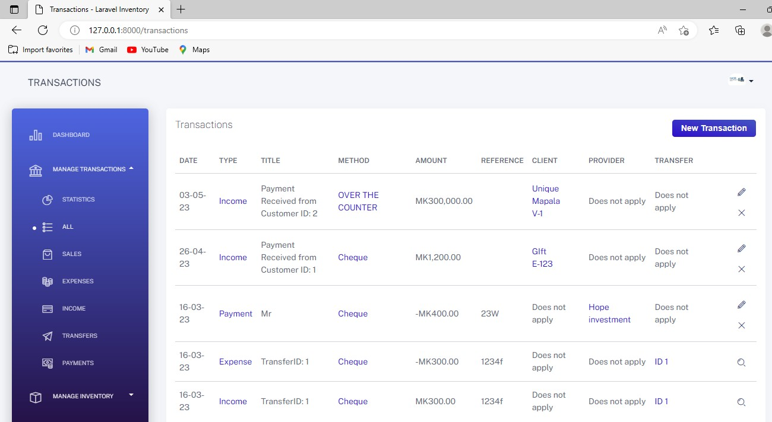

**Figure 7.3:** Manage Transaction (Transaction Statistics by type)

**LDCE** 27 **Gujarat Technological Universi**ty

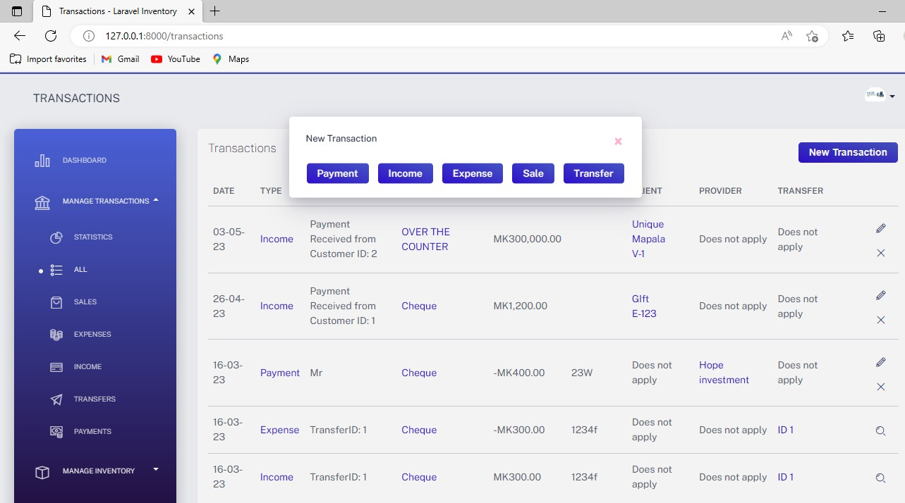

**Figure 7.4:** Transaction Page (To add new Transaction)

**LDCE** 28 **Gujarat Technological Universi**ty

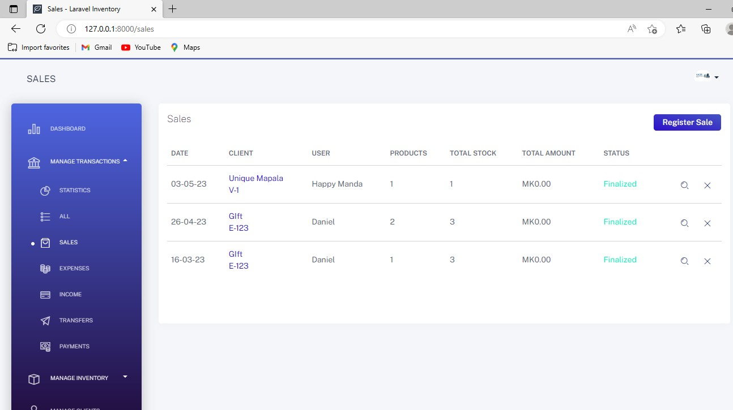

**Figure 7.5:** Sales Page (Used to Register New Sale)

**LDCE** 29 **Gujarat Technological Universi**ty

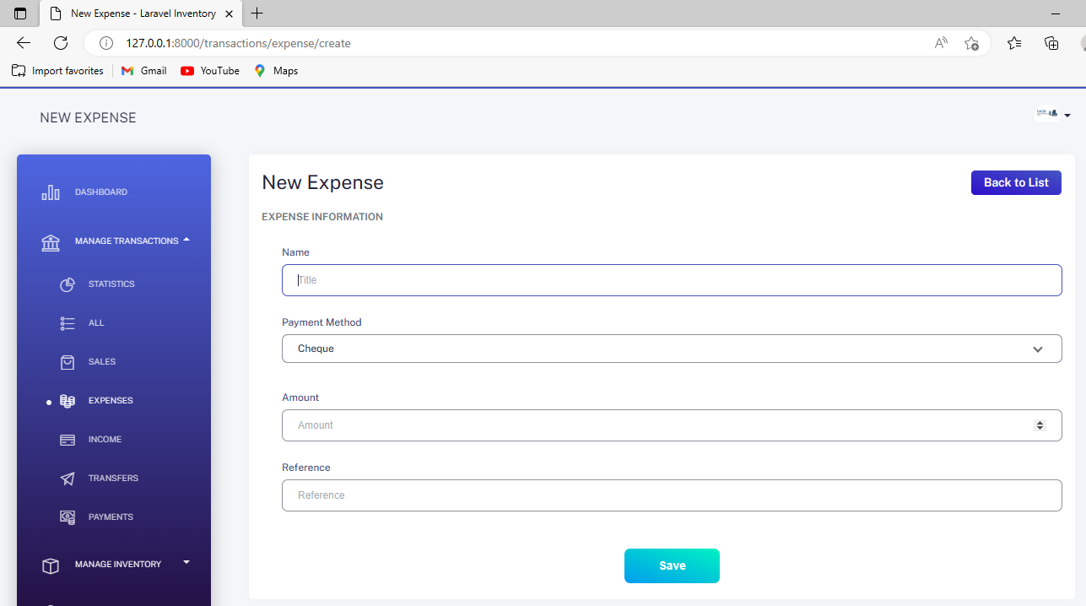

#### Figure 7.6: Expenses Page (Page)

**LDCE** 30 **Gujarat Technological Universi**ty

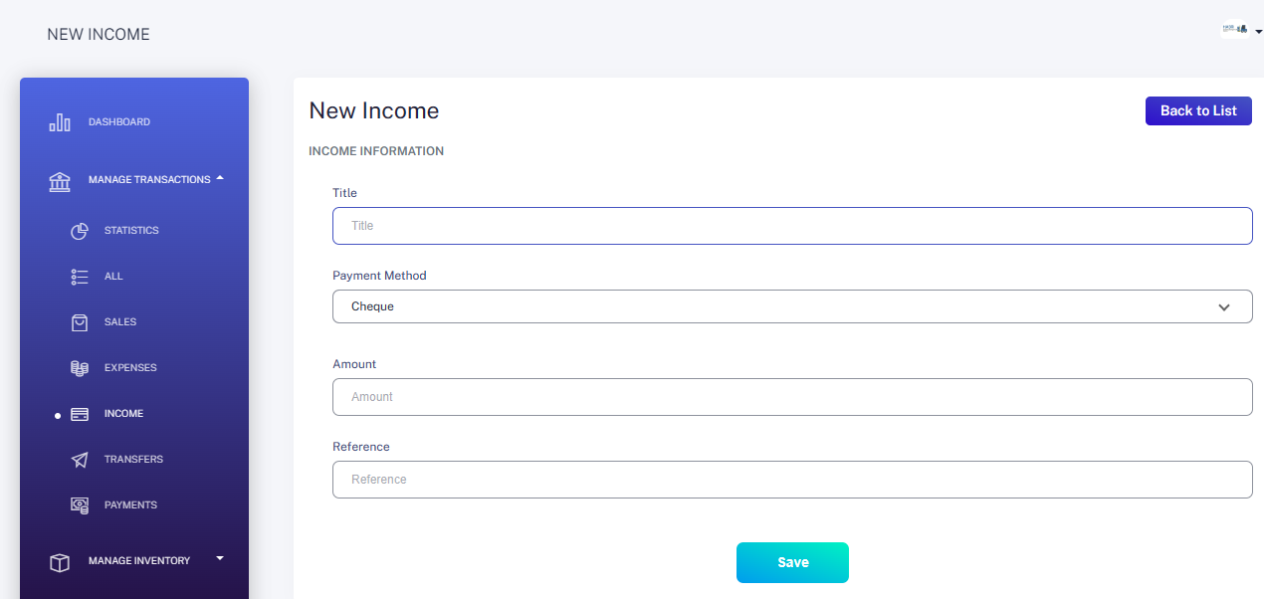

#### Figure 7.7: Income page (Page where you register income)

**LDCE** 31 **Gujarat Technological Universi**ty

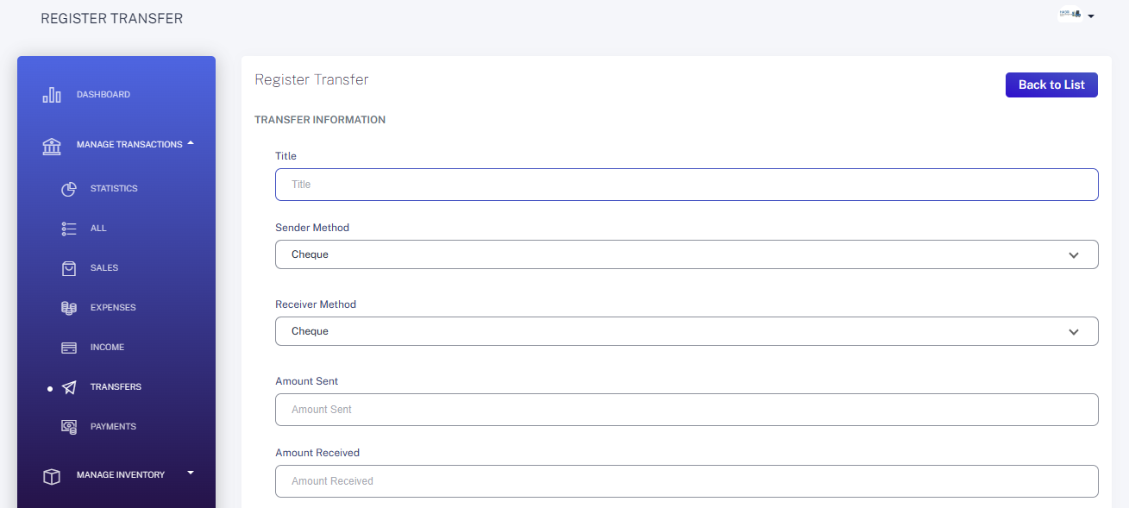

**Figure 7.8:** Transfer Page (Used to show Transferred Money)

**LDCE** 32 **Gujarat Technological Universi**ty

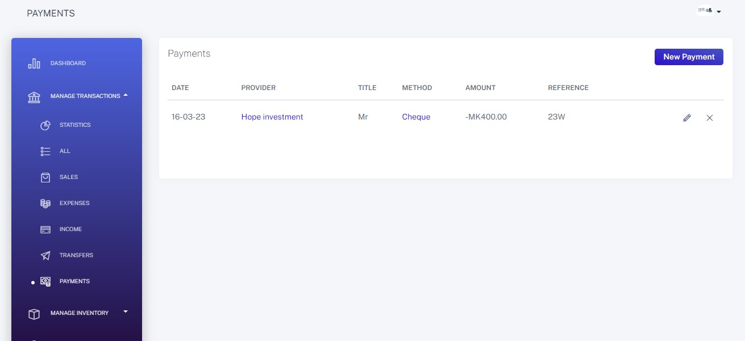

**Figure 7.9:** Payment Page (used to Register Payment)

**LDCE** 33 **Gujarat Technological Universi**ty

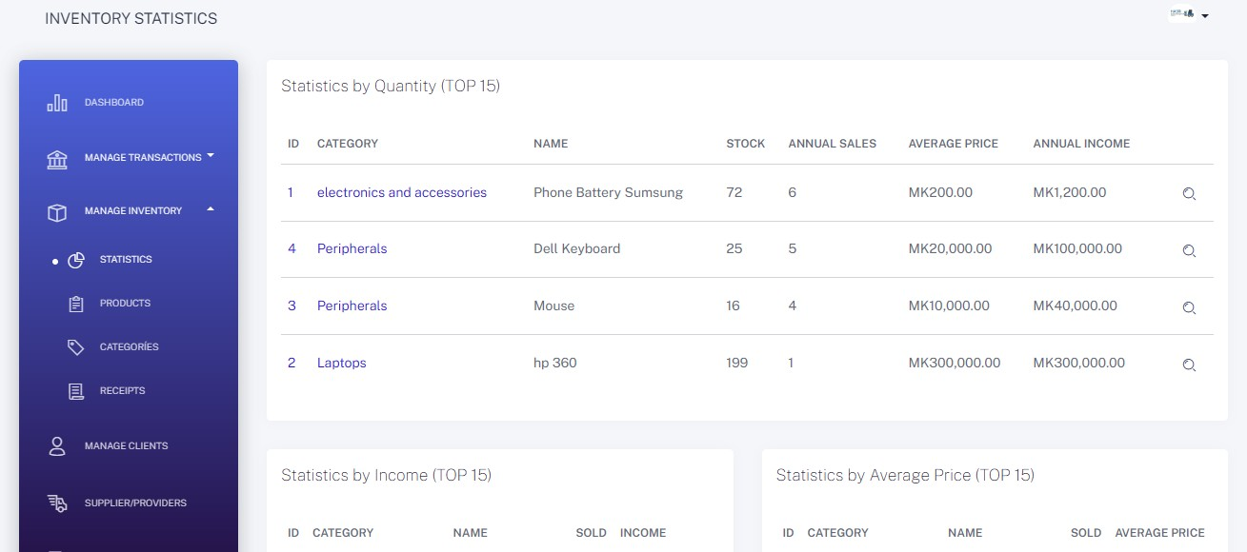

**Figure 7.10:** Page for Inventory Statistics

**LDCE** 34 **Gujarat Technological Universi**ty

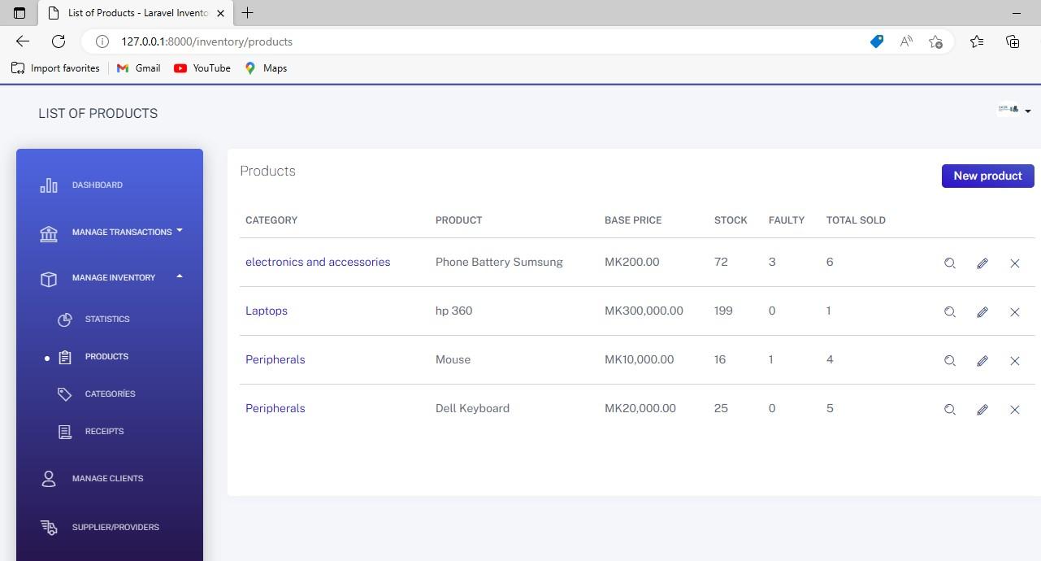

**Figure 8.0:** Page for Adding Product

**LDCE** 35 **Gujarat Technological Universi**ty

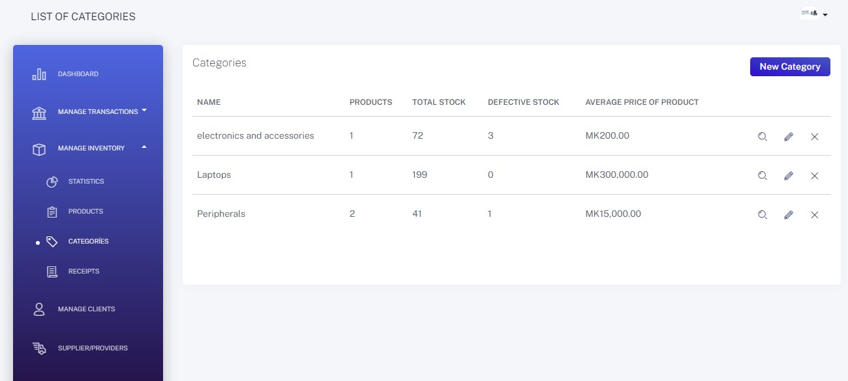

#### Figure 8.1: Page for Adding Category

**LDCE** 36 **Gujarat Technological Universi**ty

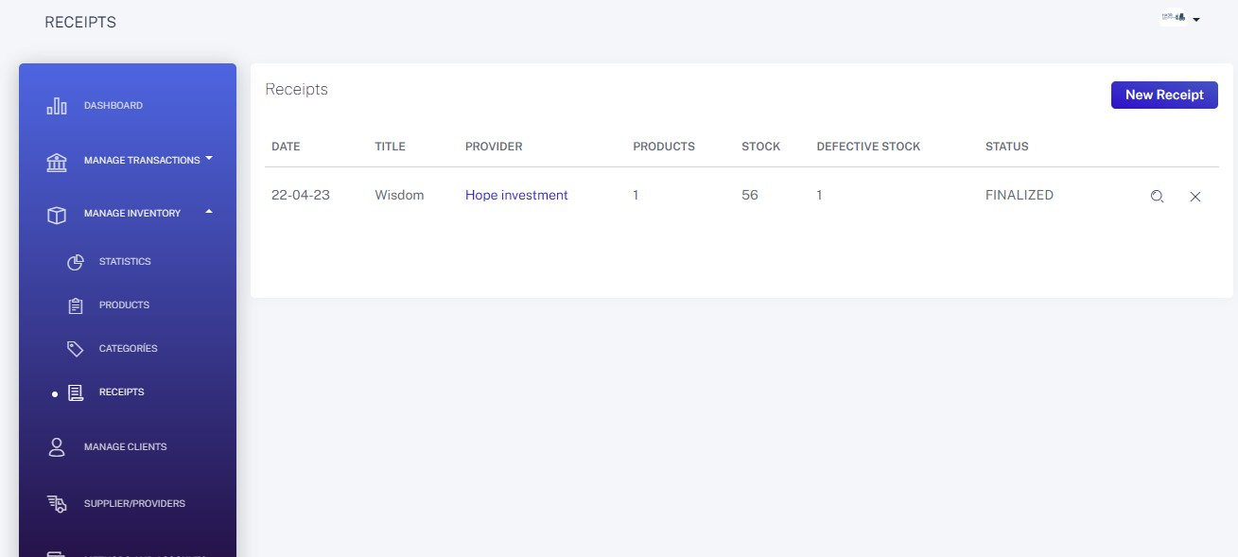

#### Figure 8.2: Receipt Page

**LDCE** 37 **Gujarat Technological Universi**ty

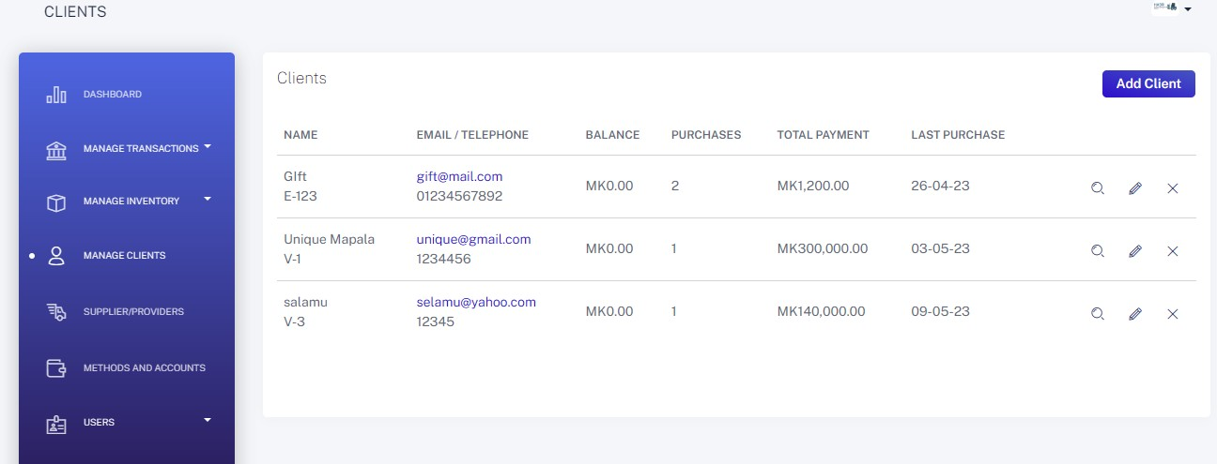

#### Figure 8.3: Manage Client Page

**LDCE** 38 **Gujarat Technological Universi**ty

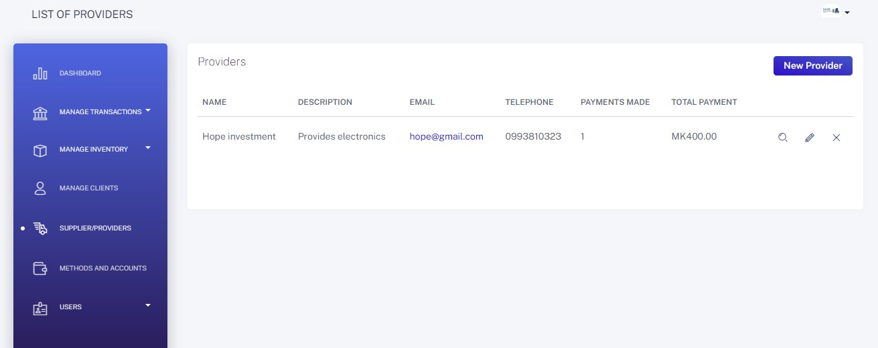

#### Figure 8.4: Manage Provider/Supplier

**LDCE** 39 **Gujarat Technological Universi**ty

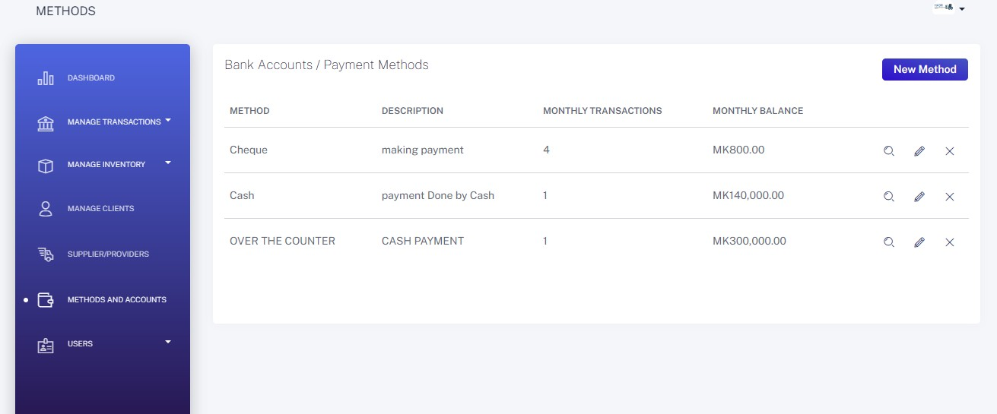

#### Figure 8.5: Page for Bank Account and Payment Methods

**LDCE** 40 **Gujarat Technological Universi**ty

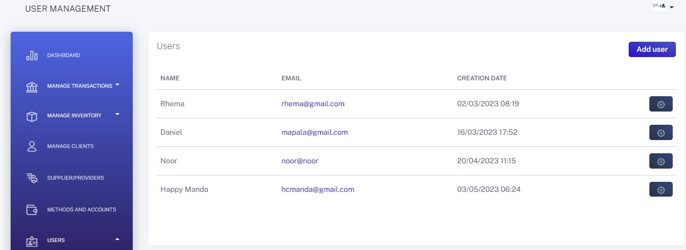

#### Figure 8.6: Page for Managing User

**LDCE** 41 **Gujarat Technological Universi**ty

## CHAPTER: DEVELOPMENT

### Agile Project Charter

|  |  |
| --- | --- |
| **Project Title:** | **Habri Inventory Management System** |
| **Project Description:** | **Development of an inventory management system for Habri Investments, a business that sells plastics, electronics, and groceries in Mzimba Boma, Malawi. The system will replace the current manual system used by the business.** |
| **Project Objectives:** | 1. **To develop a user-friendly inventory management system for Habri Investments.** 2. **To improve the accuracy and efficiency of inventory management. 3. To provide real-time visibility into inventory levels and sales.**   **4. To reduce inventory costs and minimize stock outs.** |
| **Business Case:** | **The current manual system used by Habri Investments is inefficient and prone to errors, leading to inaccurate inventory management and increased costs. The implementation of a new inventory management system will improve efficiency, accuracy, and profitability.** |
| **Project Manager:** | **Happy Abraham Manda** |
| **Project Sponsor:** | **Habri Investment** |
| **Project Team:** | **Daniel Overton Unique Mapala: 215160694035 Noor Rahim Shir Afzal:215160694038** |
| **Stakeholders:** | **Habari Investments, customers, employees** |
| **Budget:** | **TBD** |
| **Timeline:** | **Start Date: 7/02/2023 End Date: 20/05/2023** |
| **Methodology:** | **Agile** |

42

|  |  |
| --- | --- |
| **Risks:** | 1. Lack of advanced experience with the chosen technology stack. 2. Limited resources, including time and budget. 3. Changes in project scope or requirements. 4. Potential resistance to change from employees or customers. |
| **Assumptions:** | 1. The project team has access to the necessary hardware and software. 2. The project team has the required skills and knowledge to develop the system. 3. The business processes and workflows are well defined and documented. 4. The project team will have access to relevant information and support from Habri Investments. |
| **Success Criteria:** | 1. The system is delivered on time and within budget. 2. The system meets all functional requirements specified in the SRS. 3. The system is user-friendly and intuitive.   4. The system improves inventory accuracy and efficiency. |
| **Signatures:** | **Happy Abraham Manda**    **Daniel O.U Mapala**  **Noor Rahim Shir Afzal** |

#### Table 3:

43

### Agile Roadmap/ Schedule:

|  |  |  |  |
| --- | --- | --- | --- |
| **Sprint** | **Start Date** | **End Date** | **Deliverables** |
| **Sprint 1** | 07-02-2023 | 03-03-2023 | * Completed SRS * Setup development environment * Develop user authentication and authorization module |
| **Sprint 2** | 04-03-2023 | 24-03-2023 | * Develop product catalog management * Basic UI for product catalog and order management |
| **Sprint 3** | 25-03-2023 | 14-04-2023 | * Complete UI design for product catalog * Develop inventory management * Implement reporting and analytics module |
| **Sprint 4** | 15-04-2023 | 05-05-2023 | * Conduct testing and debugging * Refine UI and UX * Implement security measures * Finalize documentation |
| **Sprint 5** | 06-05-2023 | 20-05-2023 | * Conduct user acceptance testing * Finalize system deployment * Post-implementation review and evaluation * Prepare for project handover to client |

#### Table 4:

44

# Agile Project Plan

|  |  |  |  |
| --- | --- | --- | --- |
| **Task Description** | **Start Date** | **End Date** | **Duration** |
| Sprint 1 Planning Meeting and Requirement Gathering | 07-02-2023 | 09-02-2023 | 3 days |
| Develop User Interface Design and Get Approval | 10-02-2023 | 16-02-2023 | 5 days |
| Develop Database Schema and Get Approval | 17-02-2023 | 23-02-2023 | 5 days |
| Sprint 1 Coding and Unit Testing | 24-02-2023 | 10-03-2023 | 11 days |
| Sprint 1 System Testing and Bug Fixing | 11-03-2023 | 16-03-2023 | 4 days |
| Sprint 1 Acceptance Testing and Release | 17-03-2023 | 22-03-2023 | 4 days |
| Sprint 2 Planning Meeting and Requirement Gathering | 23-03-2023 | 25-03-2023 | 3 days |
| Develop User Management Module and Get Approval | 26-03-2023 | 05-04-2023 | 7 days |
| Develop Inventory Management Module and Get Approval | 06-04-2023 | 19-04-2023 | 10 days |
| Sprint 2 Coding and Unit Testing | 20-04-2023 | 06-05-2023 | 11 days |
| Sprint 2 System Testing and Bug Fixing | 07-05-2023 | 12-05-2023 | 4 days |
| Sprint 2 Acceptance Testing and Release | 13-05-2023 | 18-05-2023 | 4 days |
| Sprint 3 Planning Meeting and Requirement Gathering | 19-05-2023 | 21-05-2023 | 3 days |
| Develop Sales Management Module and Get Approval | 22-05-2023 | 28-05-2023 | 5 days |
| Develop Reporting Module and Get Approval | 29-05-2023 | 31-05-2023 | 3 days |
| Sprint 3 Coding and Unit Testing | 01-06-2023 | 14-06-2023 | 10 days |
| Sprint 3 System Testing and Bug Fixing | 15-06-2023 | 20-06-2023 | 4 days |
| Sprint 3 Acceptance Testing and Release | 21-06-2023 | 26-06-2023 | 4 days |
| Finalize User Documentation and Training Materials | 27-06-2023 | 04-07-2023 | 6 days |
| User Acceptance Testing and Deployment | 05-07-2023 | 12-07-2023 | 6 days |
| Project Review and Closure | 13-07-2023 | 14-07-2023 | 2 days |

**Figure 8:**

* 1. **Agile User Story (Minimum 3 Tasks):**
     + As a Warehouse Manager, I want to be able to add new products to the inventory, so that I can keep track of new items in stock.
     + As a Sales Representative, I want to be able to create invoices and track customer orders, so that I can provide better customer service.
     + As a Purchase Officer, I want to be able to create purchase orders and track vendor orders, so that I can ensure timely delivery of goods.

45

**215160694035/215160694038 HABRI INVENTORY MANAGEMENT SYSTEM**

### Agile Release Plan

|  |  |  |  |  |  |
| --- | --- | --- | --- | --- | --- |
| **Sprint** | **Goal** | **Start Date** | **End Date** | **Duration** | **Tasks** |
| Sprint 1 | Develop a working prototype of the user interface and database schema, as well as perform initial testing and bug fixing. | 07/02/2023 | 22/03/2023 | 7 weeks | Planning Meeting and Requirement Gathering (3 days), Develop User Interface Design and Get Approval (5 days), Develop Database Schema and Get Approval (5 days), Coding and Unit Testing (11 days), System Testing and Bug Fixing (4 days), Acceptance Testing and Release (4 days). |
| Sprint 2 | Develop the User Management and Inventory Management Modules, perform testing, and bug fixing. | 23/03/2023 | 18/05/2023 | 8 weeks | Planning Meeting and Requirement Gathering (3 days), Develop User Management Module and Get Approval (7 days), Develop Inventory Management Module and Get Approval (10 days), Coding and Unit Testing (11 days), System Testing and Bug Fixing (4 days), Acceptance Testing and Release (4 days). |
| Sprint 3 | Develop the Sales Management and Reporting Modules, perform testing, and bug fixing. | 19/05/2023 | 26/06/2023 | 6 weeks | Planning Meeting and Requirement Gathering (3 days), Develop Sales Management Module and Get Approval (5 days), Develop Reporting Module and Get Approval (3 days), Coding and Unit Testing (10 days), System Testing and Bug Fixing (4 days), Acceptance Testing and Release (4 days). |
| Final Sprint | Finalize User Documentation and Training Materials, perform User Acceptance Testing and Deployment, and perform project review and closure. | 27/06/2023 | 14/07/2023 | 3 weeks | Finalize User Documentation and Training Materials (6 days), User Acceptance Testing and Deployment (6 days), Project Review and Closure (2 days). |

**Table 5:**

46

### Agile Sprint Backlog:

#### Sprint 1:

|  |  |
| --- | --- |
| Task | Priority |
| Develop User Interface Design | **High** |
| Develop Database Schema | **High** |
| Coding and Unit Testing | **High** |
| System Testing and Bug Fixing | **Medium** |
| Acceptance Testing and Release | **Medium** |

**Sprint 2:**

|  |  |
| --- | --- |
| Task | Priority |
| Develop User Management Module | **High** |
| Develop Inventory Management Module | **High** |
| Coding and Unit Testing | **High** |
| System Testing and Bug Fixing | **Medium** |
| Acceptance Testing and Release | **Medium** |

#### Sprint 3:

|  |  |
| --- | --- |
| Task | Priority |
| Develop Sales Management Module | **High** |
| Develop Reporting Module | **High** |
| Coding and Unit Testing | **High** |
| System Testing and Bug Fixing | **Medium** |
| Acceptance Testing and Release | **Medium** |

**Final Sprint:**

|  |  |
| --- | --- |
| Task | Priority |
| Finalize User Documentation and Training Materials | **Medium** |
| User Acceptance Testing and Deployment | **High** |
| Project Review and Closure | **Medium** |

#### Table: 6

47

### Agile Test Plan

|  |  |  |
| --- | --- | --- |
| **Test**  **Item** | **Description** | **Team** |
| User Interface | Ensure that the user interface is intuitive and easy to  use. | Daniel and  Noor |
| Login and  Authentication | Verify that users can successfully log in and that  authentication processes are secure. | Noor |
| Inventory Management | Confirm that the system accurately tracks inventory levels and that it updates in real-time as items are  added or sold. | Daniel |
| Reporting and Analytics | Test the system's reporting and analytics capabilities, including the ability to generate sales reports, inventory summaries, and other key  metrics. | Daniel and Noor |
| Security and  Performance | Verify that the system is secure and performs well  under heavy user loads. | Noor |
| Compatibility  Testing | Test the system's compatibility with different  operating systems, browsers, and devices. | Daniel |
| Integration Testing | Verify that the system integrates seamlessly with third-party tools and services, such as payment  gateways and shipping providers. | Daniel and Noor |

**Table: 7**

48

### Agile Burn down chart:

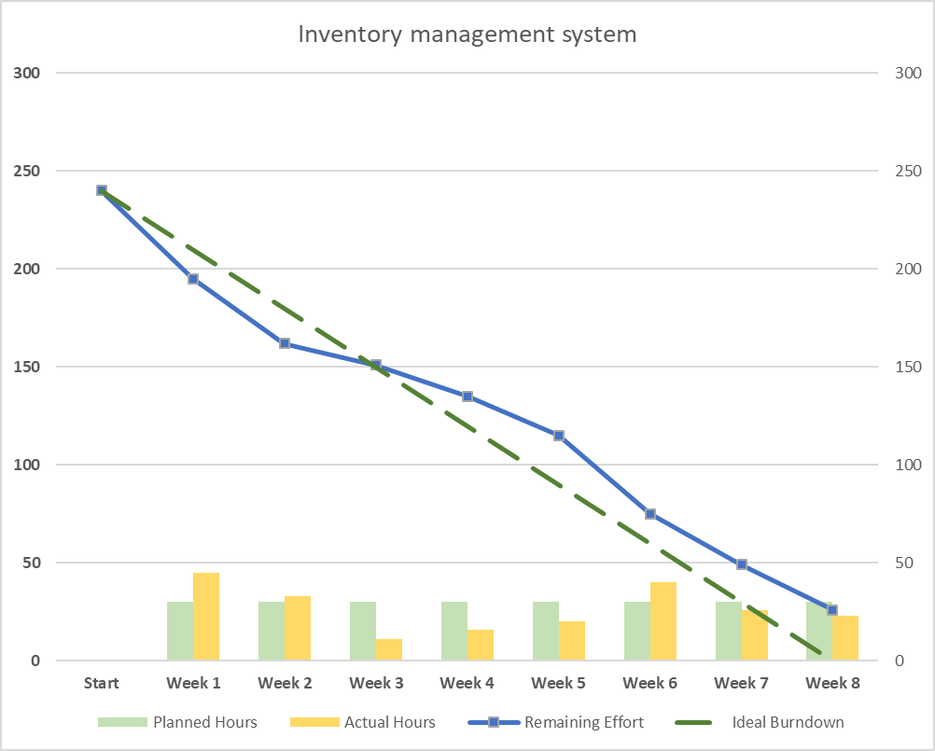

#### Figure:9

49

1. **CHAPTER: LEARNING DURING PROJECT WORK**

As students developing the Habri Inventory Management System, here are some lessons learned:

1. **Importance of Planning:** We realized the significance of thorough planning before diving into development. It helped us establish a clear project scope, define requirements, and create a structured roadmap. This enabled us to stay focused and organized throughout the development process.
2. **Utilizing Framework Capabilities**: Working with the Laravel framework and other technologies used taught us the advantages of using a well-established framework for web development. We learned to leverage the built-in features and libraries of Laravel, such as authentication, routing, and database management, which significantly streamlined our development efforts.
3. **Collaboration and Teamwork:** Developing a system as a team highlighted the importance of effective communication and collaboration. Regular meetings, assigning tasks, and maintaining open lines of communication allowed us to share ideas, resolve challenges together, and ensure everyone was on the same page.
4. **Version Control and Documentation:** We recognized the significance of utilizing version control systems, such as Git, to manage code changes and collaborate seamlessly. Additionally, we learned the importance of documenting our code, including comments and clear documentation, to enhance code readability and facilitate future maintenance and troubleshooting.
5. **Testing and Quality Assurance:** Implementing rigorous testing and quality assurance measures proved vital in ensuring the system's stability and functionality. We learned to perform unit tests, integration tests, and user acceptance tests to identify and resolve bugs and ensure a smooth user experience.
6. **Continuous Learning and Adaptability:** Developing the Habri Inventory Management System taught us the value of continuous learning and adapting to new technologies and practices. We had to stay updated with Laravel framework

50

updates, industry best practices, and emerging trends to deliver a robust and modern system.

1. **Time Management:** Managing our time effectively was crucial throughout the project. We learned to prioritize tasks, set realistic deadlines, and allocate time for research and problem-solving. This allowed us to meet project milestones and deliver a high-quality system within the given timeframe.

These lessons helped us gain valuable experience in software development, project management, teamwork, and adaptability, preparing us for future projects and professional endeavours.

51

## CHAPTER: PROPOSED ENHANCEMENTS

Some proposed enhancements for the inventory management system include:

* + - Integration with third-party logistics providers to track shipments and deliveries
    - Integration with accounting software to manage finances and generate financial reports
    - Integration with customer relationship management software to manage customer information and provide personalized service

52

## CHAPTER: CONCLUSION

In conclusion, the inventory management system developed using Laravel Framework is an efficient and effective tool for managing the organization's inventory. The system helps the Company to reduce errors and inaccuracies in inventory management, improve productivity, streamline the inventory management process, and provide real- time data for better decision making. The system is scalable, modular, and flexible to meet the organization's future needs.

53

## CHAPTER REFERENCES/BIBLIOGRAPHY

1. IEEE Std 830-1998, IEEE Recommended Practice for Software Requirements Specifications, IEEE Computer Society, 1998.
2. Pressman, R.S. Software Engineering: A Practitioner's Approach, 8th Edition. McGraw-Hill Education, 2014.
3. <https://laracasts.com/series/laravel-6-from-scratch>
4. <https://laravel.com/docs/8.x>
5. <https://www.php.net/docs.php>
6. <https://dev.mysql.com/doc/>
7. <https://getbootstrap.com/docs/5.1/getting-started/introduction/>
8. <https://www.w3schools.com/html/>
9. <https://www.w3schools.com/css/>
10. <https://github.com/>
11. <https://trello.com/>
12. <https://www.atlassian.com/software/jira>
13. <https://slack.com/>
14. <https://git-scm.com/doc>
15. <https://httpd.apache.org/docs/>
16. <https://nginx.org/en/docs/>
17. <https://www.heroku.com/>
18. <https://www.digitalocean.com/>
19. <https://cloud.google.com/>

54